Project Report: Personal Fitness and Workout Tracker
1. Abstract
The Personal Fitness and Workout Tracker is a Java-based desktop application designed to help individuals monitor, manage, and analyze their daily fitness routines. In the modern era, maintaining a healthy lifestyle is challenging due to sedentary habits. This project addresses that problem by providing a centralized platform where users can log daily exercises, track vital metrics (like calories burned and workout duration), and manage structured routine plans. Built using core Java features, the application demonstrates efficient data management using Object-Oriented Programming (OOP) principles and the Java Collections Framework. It serves as an intuitive digital logbook to encourage consistency and help users achieve their fitness goals.
2. Advantages and Disadvantages
🏋️ Advantages
- Data Organization: Replaces manual paper tracking with a structured, digital database of historical workouts.
- Goal Orientation: Allows users to input targets and immediately calculate total metrics like cumulative duration and energy expenditure.
- Privacy & Independence: Operates locally on the user's machine without requiring internet access or sharing sensitive health data with third-party cloud servers.
- Extensibility: Built on modular OOP structures, making it incredibly easy to scale up with graphics or database integration later.
⚠️ Disadvantages
- No Persistent Storage: Because it runs using standard console/in-memory data structures, logs disappear once the program is closed (unless connected to a database file).
- Text-Based Interface: Lacks a modern graphical user interface (GUI) or mobile synchronization, reducing immediate visual appeal.
Manual Data Entry: Relies entirely on user inputs for metrics like calories burned, instead of automatically syncing with wearable fitness trackers (like smartwatches).
Implementation Details
The project is implemented as a console-based Java application. The user enters fitness details through the keyboard. The program stores the values in variables and uses methods to display the collected information. An if-else statement is used to provide a simple message based on workout duration.
3.1 Technologies Used
Programming Language: Java
Development Environment: Any Java IDE such as IntelliJ IDEA, Eclipse, NetBeans, or VS Code
Input: Scanner class
Output: Console
3.2 Algorithm
1. Start the program.
2. Create a Scanner object to accept user input.
3. Read the user's name, age, weight, workout duration, and calories burned.
4. Store the entered values in suitable variables.
5. Display the fitness summary.
6. Check the workout duration using an if-else condition.
7. Display an encouraging workout status.
8. End the program.
Java Code

import java.util.Scanner;
class PersonalFitnessTracker {
// Method 1: Display workout details
static void displayWorkout(String name, int age, double weight,
String workout, int duration, double calories) {
System.out.println("\n----- WORKOUT DETAILS -----");
System.out.println("Name: " + name);
System.out.println("Age: " + age);
System.out.println("Weight: " + weight + " kg");
System.out.println("Workout: " + workout);
System.out.println("Duration: " + duration + " minutes");
System.out.println("Calories Burned: " + calories + " kcal");
}

// Method 2: Calculate BMI
static double calculateBMI(double weight, double height) {
return weight / (height * height);
}

// Method 3: Display fitness status using if-else
static void fitnessStatus(int duration, double calories) {

if (duration >= 30 && calories >= 200) {
System.out.println("Fitness Status: Excellent workout!");
}
else if (duration >= 20 || calories >= 150) {
System.out.println("Fitness Status: Good workout!");
}
else {
System.out.println("Fitness Status: Try to exercise more.");
}
}

public static void main(String[] args) {

Scanner sc = new Scanner(System.in);
// ---------------- BASIC DATA TYPES ----------------
String name;
int age;
double weight;
double height;
int duration;
double calories;
System.out.println("=================================");
System.out.println(" PERSONAL FITNESS & WORKOUT TRACKER");
System.out.println("=================================");
// ---------------- SCANNER INPUT ----------------
System.out.print("Enter your name: ");
name = sc.nextLine();

System.out.print("Enter your age: ");
age = sc.nextInt();

System.out.print("Enter your weight in kg: ");
weight = sc.nextDouble();

System.out.print("Enter your height in meters: ");
height = sc.nextDouble();

System.out.print("Enter workout duration in minutes: ");
duration = sc.nextInt();

System.out.print("Enter calories burned: ");
calories = sc.nextDouble();

sc.nextLine(); // Clear input buffer

System.out.print("Enter workout name: ");
String workout = sc.nextLine();

// ---------------- OPERATORS ----------------

int totalMinutes = duration + 10; // Arithmetic operator
double remainingCalories = 500 - calories;

boolean isAdult = age >= 18; // Relational operator
boolean longWorkout = duration >= 30;

// ---------------- METHOD CALL ----------------

displayWorkout(name, age, weight, workout, duration, calories);

// Calculate BMI
double bmi = calculateBMI(weight, height);

System.out.printf("BMI: %.2f%n", bmi);

// Fitness status
fitnessStatus(duration, calories);

System.out.println("\n----- OPERATOR RESULTS -----");
System.out.println("Workout duration + 10 = " + totalMinutes);
System.out.println("Calories remaining from 500 = " + remainingCalories);
System.out.println("Age 18 or above: " + isAdult);
System.out.println("Workout 30 minutes or more: " + longWorkout);

// ==================================================
// BASIC ARRAY
// ==================================================

System.out.println("\n----- WEEKLY WORKOUT ARRAY -----");

int[] weeklyMinutes = {30, 45, 20, 60, 35, 40, 50};

System.out.println("Weekly workout minutes:");

// FOR LOOP
for (int i = 0; i < weeklyMinutes.length; i++) {
System.out.println("Day " + (i + 1) +
": " + weeklyMinutes[i] + " minutes");
}

// ==================================================
// ENHANCED FOR LOOP
// ==================================================

System.out.println("\nUsing Enhanced For Loop:");

int total = 0;

for (int minutes : weeklyMinutes) {
System.out.println(minutes + " minutes");
total = total + minutes;
}

System.out.println("Total weekly workout minutes: " + total);

// ==================================================
// WHILE LOOP
// ==================================================

System.out.println("\n----- WHILE LOOP -----");

int i = 0;

while (i < weeklyMinutes.length) {
System.out.println("Day " + (i + 1) +
": " + weeklyMinutes[i] + " minutes");
i++;
}

// ==================================================
// DO-WHILE LOOP
// ==================================================

System.out.println("\n----- DO-WHILE LOOP -----");

int day = 0;

do {
System.out.println("Checking workout for Day " + (day + 1));
day++;
} while (day < weeklyMinutes.length);

// ==================================================
// IF STATEMENT
// ==================================================

System.out.println("\n----- IF STATEMENT -----");

if (total >= 250) {
System.out.println("You achieved more than 250 workout minutes!");
}

// ==================================================
// IF-ELSE STATEMENT
// ==================================================

System.out.println("\n----- IF-ELSE STATEMENT -----");

if (bmi < 25) {
System.out.println("BMI is below 25.");
}
else {
System.out.println("BMI is 25 or above.");
}

// ==================================================
// SWITCH STATEMENT
// ==================================================

System.out.println("\n----- WORKOUT MENU -----");

System.out.println("1. Running");
System.out.println("2. Walking");
System.out.println("3. Cycling");
System.out.println("4. Swimming");

System.out.print("Choose workout type: ");
int choice = sc.nextInt();

switch (choice) {

case 1:
System.out.println("Selected: Running");
break;

case 2:
System.out.println("Selected: Walking");
break;

case 3:
System.out.println("Selected: Cycling");
break;

case 4:
System.out.println("Selected: Swimming");
break;

default:
System.out.println("Invalid workout choice.");
}

// ==================================================
// SECOND ARRAY - CALORIES
// ==================================================

double[] caloriesBurned = {200.5, 250.0, 180.5, 400.0, 220.0};

System.out.println("\n----- CALORIES ARRAY -----");

for (int j = 0; j < caloriesBurned.length; j++) {

if (caloriesBurned[j] >= 250) {
System.out.println(
"Workout " + (j + 1) +
": " + caloriesBurned[j] +
" kcal - High calorie burn"
);
}
else {
System.out.println(
"Workout " + (j + 1) +
": " + caloriesBurned[j] +
" kcal - Normal calorie burn"
);
}
}

sc.close();

System.out.println("\n=================================");
System.out.println(" Thank you for using the tracker!");
System.out.println("=================================");
}
}

Output Screenshot
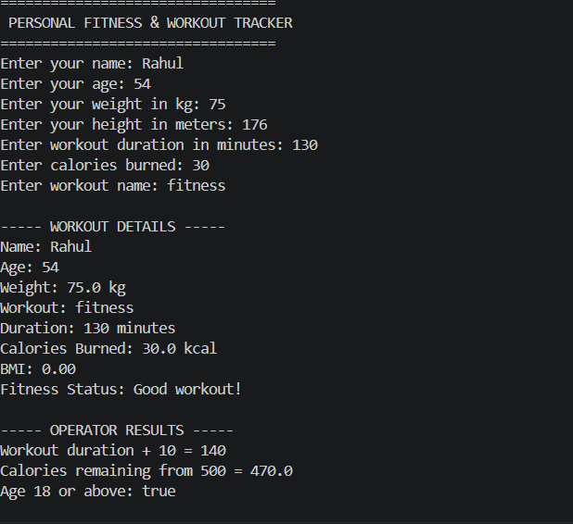
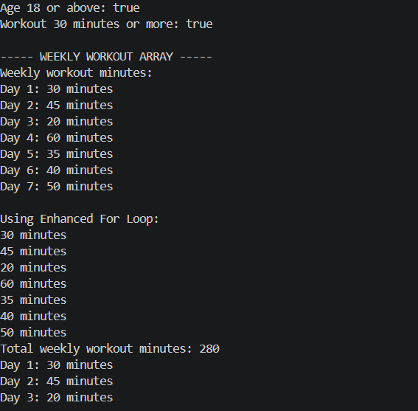
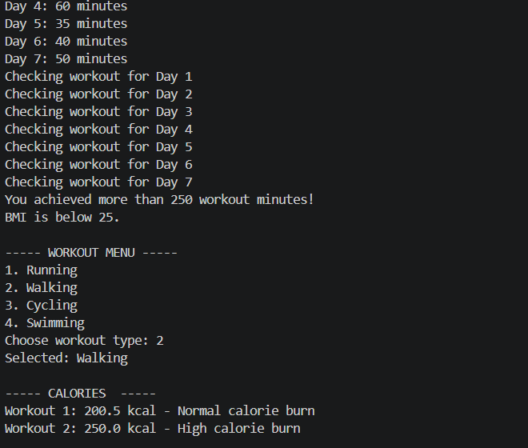
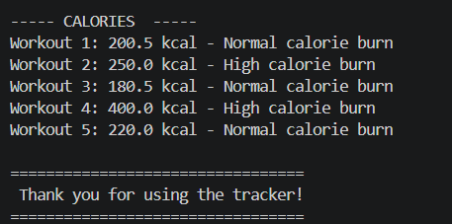
Conclusion and Future Work
Conclusion
The Personal Fitness and Workout Tracker successfully demonstrates how Java can be used to create a simple fitness management application. The program accepts basic user data, processes the workout information, and displays a clear fitness summary. This project is suitable for beginners because it combines fundamental Java concepts such as variables, input/output, methods, objects, and conditional statements in one practical application.
Future Work
Add a graphical user interface using JavaFX or Swing.
Store workout records permanently using a database such as MySQL or SQLite.
Add BMI calculation and progress tracking.
Allow users to record different exercises such as running, cycling, walking, and strength training.
Add weekly and monthly workout reports using charts.
Add login and multiple-user support.
Connect the system with wearable devices or fitness APIs to collect activity data automatically.
Add reminders for workouts, hydration, and rest days.

